FIN 810 Financial Analytics

Midterm exam 2019

Name:Priyadarshini De

1. Write down your main answers in the exam paper. Email your analysis (EXCEL/SAS code/SAS log/SAS result) to [xz4@stmarys-ca.edu](mailto:xz4@stmarys-ca.edu).
2. Keep 4 decimal places for all your answers.

Part One: Excel Questions (10 points)

1. The table below gives a portfolio’s annual total return for a 12-year period ending in2016.

|  |  |
| --- | --- |
| 2005 | -7.14% |
| 2006 | 1.62% |
| 2007 | 2.48% |
| 2008 | -2.59% |
| 2009 | 9.37% |
| 2010 | -0.55% |
| 2011 | -0.89% |
| 2012 | -9.19% |
| 2013 | -5.11% |
| 2014 | -0.49% |
| 2015 | 6.84% |
| 2016 | 3.04% |

1. Find the geometric mean of the portfolio’s return (you can use Excel)

I used SAS studio to calculate Geometric mean.

data exam;

input year return;

datalines;

2005 -.0714

2006 .0162

2007 .0248

2008 -.0259

2009 .0937

2010 -.0055

2011 -.0089

2012 -.0919

2013 -.0511

2014 -.0049

2015 .0684

2016 .0304

; run;

/*1. Geometric mean*/

data exam_geo;

set exam; return_1=return+1; run;

proc surveymeans data=exam_geo geomean;

var return_1; run;

Result:

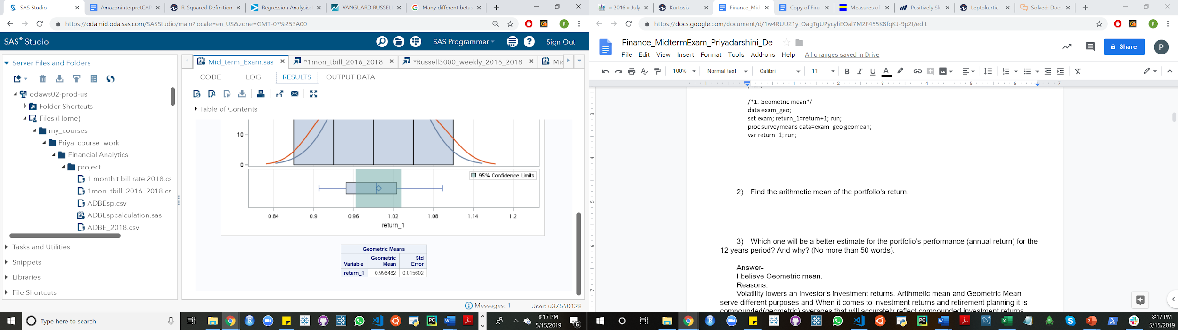

1. Find the arithmetic mean of the portfolio’s return.

/*2. Arithmetic mean */

proc means data=exam; var return; run;

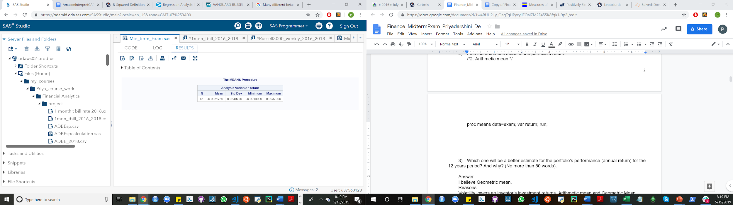

1. Which one will be a better estimate for the portfolio’s performance (annual return) for the 12 years period? And why? (No more than 50 words).

Answer-

I believe Geometric mean.

Reasons:

Volatility lowers an investor’s investment returns. Arithmetic mean and Geometric Mean serve different purposes and When it comes to investment returns and retirement planning it is compounded(geometric) averages that will accurately reflect compounded investment returns. Arithmetic averages will always over state investment returns unless there is zero volatility.

Part Two: SAS questions: Stock NVIDIA

Use the NVIDIA’s weekly data from Yahoo Finance from 1/3/2016-12/31/2018. The screen shot of data download is as follows. The data is on SAS studio, Middle term exam.

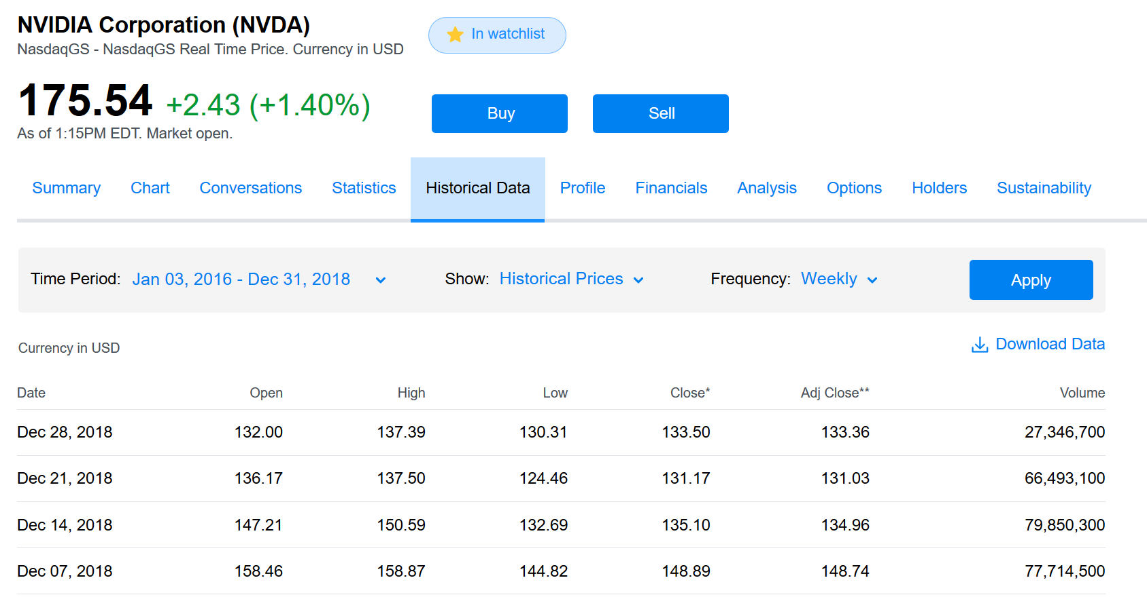

1. Statistics of NVIDIA weekly returns (Use SAS. Please submit SAS codes) (40 points)
2. Arithmetic mean

/*Part two Statistics of NVDIA weekly returns*/

proc import out=NVIDIA

datafile="/home/u37560128/my_courses/xz400/midterm 2019/NVDA weekly price 2016 2018.csv"

dbms=csv replace;

getnames=yes;

run;

/*Weekly return*/

data NVIDIA; set NVIDIA;

ret=Adj_Close/lag(Adj_Close)-1; run;

/*Arithmetic mean*/

proc means; var ret; run;

Result:

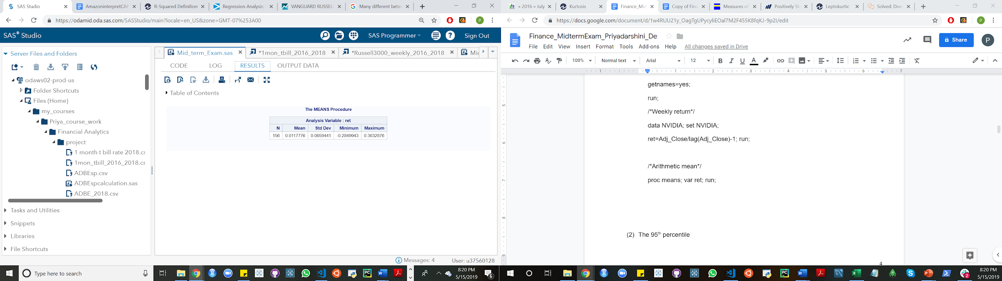

1. The 95th percentile

/*Percentile*/

proc means data=NVIDIA p95; var ret; run;

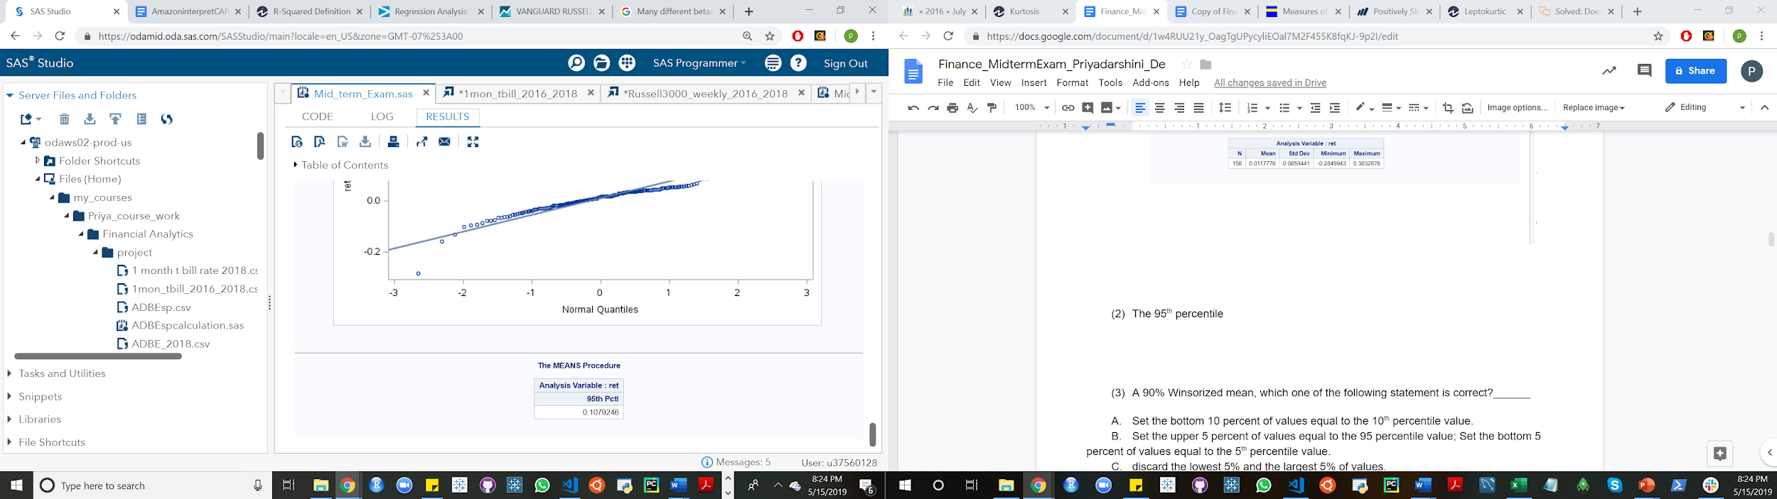

1. A 90% Winsorized mean, which one of the following statement is correct?______
2. Set the bottom 10 percent of values equal to the 10th percentile value.
3. Set the upper 5 percent of values equal to the 95 percentile value; Set the bottom 5 percent of values equal to the 5th percentile value.
4. discard the lowest 5% and the largest 5% of values.
5. discard the lowest 10% and the largest 10% of values.
6. None of the above.

Answer is:

B. “Set the upper 5 percent of values equal to the 95 percentile value; Set the bottom 5 percent of values equal to the 5th percentile value.” is correct.

1. For NVDA’s weekly returns, find ONE of the following two: either the 90% Winsorized mean; or the 90% trimmed mean.

The 90% trimmed mean is the mean of the values

after truncating the lowest and highest 5% of the values.

The Winsorized and Trimmed Means are insensitive to Outliers.

They should be reported rather than mean when the data is highly skewed.

Trimmed Mean : Removing extreme values and then calculate mean after filtering out the extreme values. 10% Trimmed Mean means calculating 10th and 90th percentile values and removing values above these percentile values.

Winsorized Mean : Capping extreme values and then calculate mean after capping extreme values at kth percentile level. It is same as trimmed mean except removing the extreme values, we are capping at kth percentile level.

code:

/*we are calculating 90% Winsorized Mean.*/

ods select winsorizedmeans;

ods output winsorizedmeans=means;

proc univariate winsorized = 0.05 data=NVIDIA;

var ret;

run;

/*we are calculating 90% trimmed Mean.*/

ods select trimmedmeans;

ods output trimmedmeans=means;

proc univariate trimmed = 0.05 data=NVIDIA;

var ret;

run;

Result:

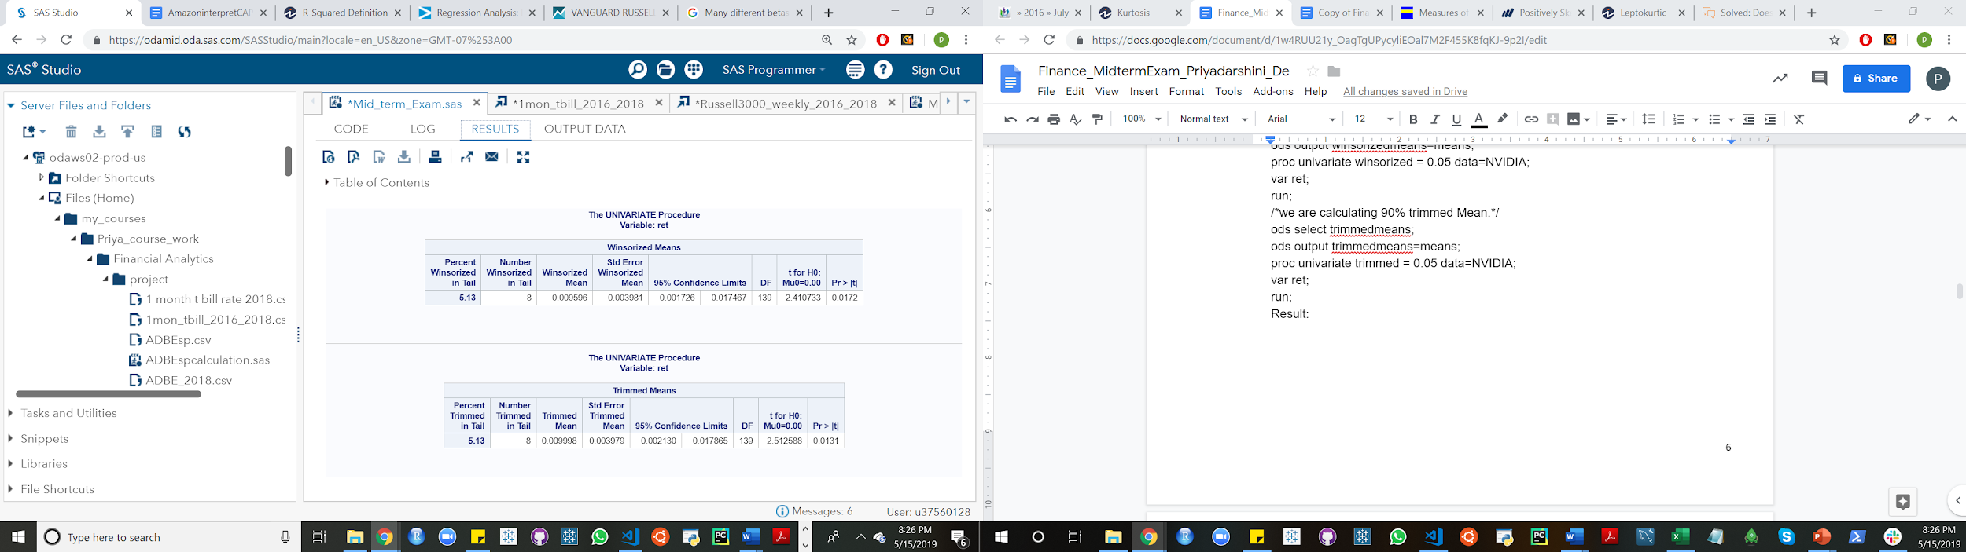

1. Standard deviation

/*Standard deviation*/

proc univariate data=NVIDIA noprint; var ret;

output out=std std=stddev; run;

proc print data=std; run;

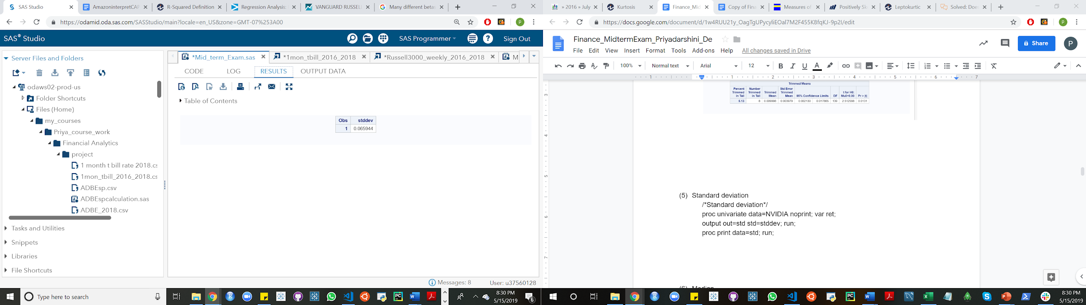

1. Median

/*Median*/

proc univariate data=NVIDIA noprint; var ret;

output out=std median=Median; run;

proc print data=std; run;

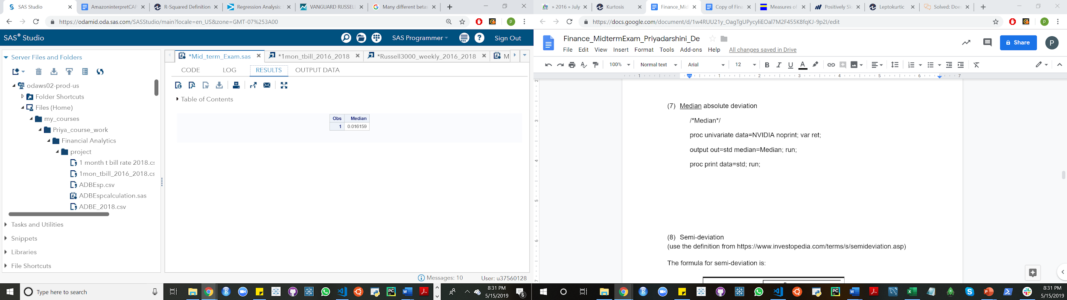

1. Median absolute deviation- 0.0162

proc means data=nvidia noprint;

var ret;

output out=averet(drop=_type_ _freq_) median= /autoname;

run;

data averet;

set averet;

label ret_median='ret_Median'; run;

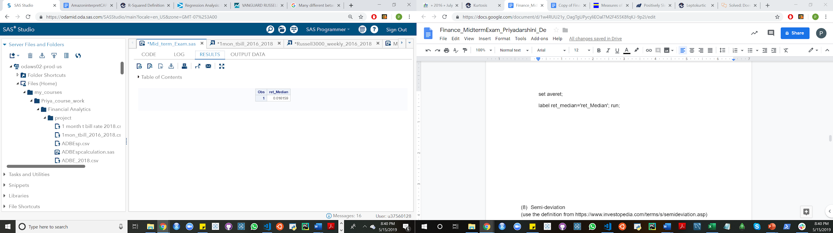

1. Semi-deviation - 0.0444

(use the definition from <https://www.investopedia.com/terms/s/semideviation.asp>)

The formula for semi-deviation is:

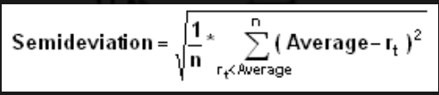

Where:

* *n* = the total number of observations below the mean (Different from the textbook’s definition)
* *rt* = the observed value
* *average* = the mean of a data set

/*MAD*/

proc means data=nvidia noprint;

var ret;

output out=averet(drop=_type_ _freq_) median= mean= /autoname;

run;

data averet;

set averet;

label ret_median='ret_Median'; run;

proc print data=averet; run;

proc sql;

create table NVIDIA_stat as select * from nvidia, averet; run;

data NVIDIA_stat;

set NVIDIA_stat;

absmeandev=abs(ret-ret_mean);

run;

proc univariate data=NVIDIA_stat;

var absmeandev; run;

/*Semi deviation*/

data nvidia2;

set NVIDIA_stat;

where ret<=ret_mean;

run;

data semi_dev;

set nvidia2;

numerator=(ret-ret_mean)**2;

run;

proc means data=semi_dev;

var numerator;

output out=midterm2

sum=numsum;

run;

proc means data=nvidia noprint; var ret;

output out=averet(drop=_type_ _freq_) mean= n= / autoname;

run;

proc sql;

create table semi_dev2 as select *

from midterm2,averet;

run;

/*Semi-deviation*/

data semi_dev2; set semi_dev2;

semi_deviation=sqrt(numsum/(ret_N-1)); run;

proc print data=semi_dev2; run;

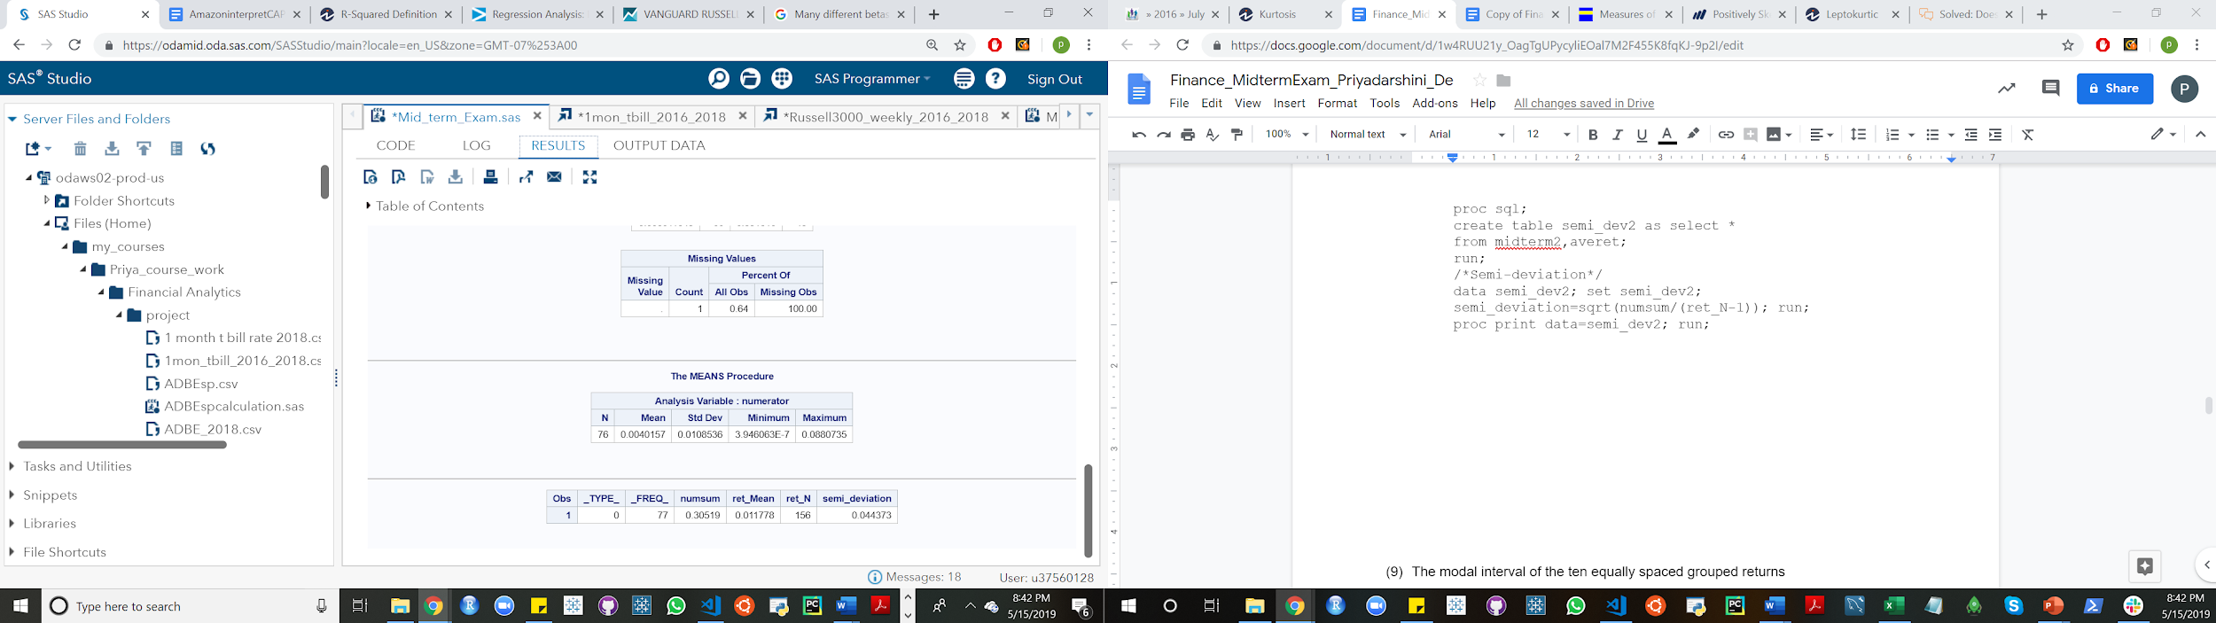

1. The modal interval of the ten equally spaced grouped returns

/* 9Q Modal interval of 10 equally spaced grouped returns*/

proc hpbin data=NVIDIA output=Modal_stats numbin=10 bucket;

input ret; run;

proc print data=Modal_stats; run;

1. Skewness:

/*10Q Skewness

Skewness is a measure of the degree of asymmetry of a distribution.

If skewness is close to 0, it means data is normal.

*/

ods select Moments;

proc univariate data=NVIDIA;

var ret; run;

result:

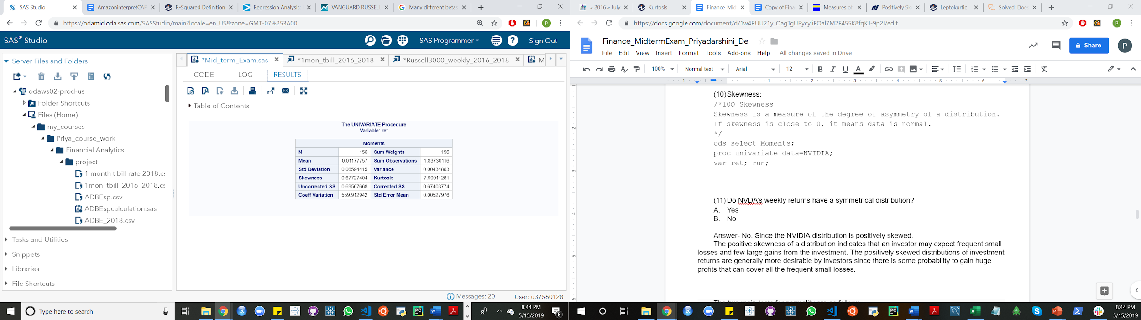

skewness between 0.5 and +1, the distribution is moderately skewed..

A positive skewed data means that there are a few extreme large

values which turns its mean to skew positively. It is also called right skewed.

1. Do NVDA’s weekly returns have a symmetrical distribution?
   1. Yes
   2. No

/*Q11. (11) Do NVDA’s weekly returns have a symmetrical distribution

Ans- Histogram shows visually whether data is normally distributed.*/

proc univariate data=NVIDIA noprint;

var ret;

Histogram/ Normal(COLOR=RED); run;

/*A symmetric distribution is a type of distribution where the left side of the distribution

mirrors the right side.

By definition, a symmetric distribution is never a skewed distribution.

A normal distribution is a symmetric distribution*/

ods select TestsforNormality;

proc univariate data=NVIDIA normal;

var ret; run;

/*Answer B not symmetric distribution.*/

Answer- No. Since the NVIDIA distribution is positively skewed.

The positive skewness of a distribution indicates that an investor may expect frequent small losses and few large gains from the investment. The positively skewed distributions of investment returns are generally more desirable by investors since there is some probability to gain huge profits that can cover all the frequent small losses.

1. Consider the figures below. Which figure is more likely to represent NVDA’s weekly returns’ distribution?

A.

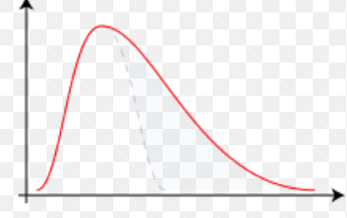

B.

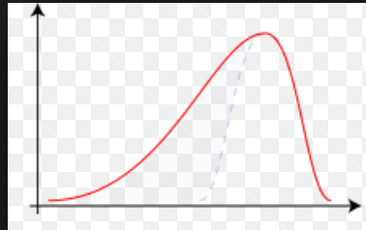

C.

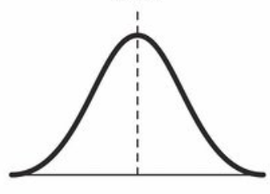

Answer- Figure A

A positively skewed(or right-skewed) distribution in which most values are clustered around the left tail of the distribution while the right tail of the distribution is longer.

In positively skewed data the measures of Central Tendency are dispersed. Here, Mean > Median> Mode.

13) Kurtosis

/*Kurtosis*/

proc means data=NVIDIA kurtosis;

var ret; run;

/*Kurtosis is greater than 3, data set has heavier tails than the normal distribution.*/

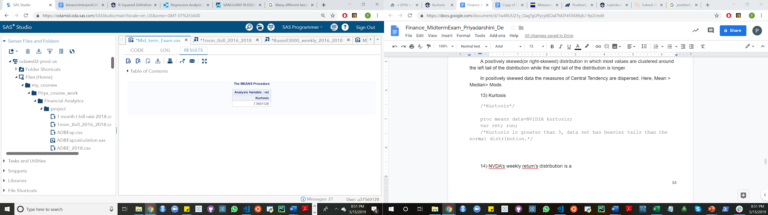

14) NVDA’s weekly return’s distribution is a

A. leptokurtic

B. platykurtic

C. mesokurtic (identical to the normal distribution)

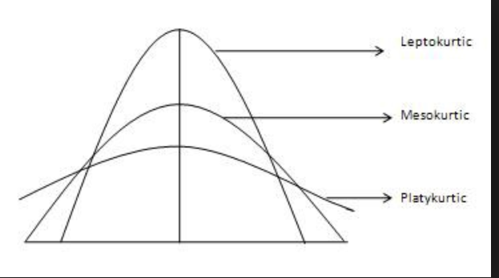

Answer: A Leptokurtic.

Leptokurtic distributions are characterised by a kurtosis coefficient greater than 3.

15) Does NVDA’s weekly return have a normal distribution? Briefly list three reasons (no more than 30 words)?

No.

1.It is not symmetric.

2.If skewness is equal to 0, it means that data is normal. When it is not.

3. The tests are against normal distribution:-

Shapiro Wilk Test [Sample Size <= 2000]

It states that the null hypothesis - distribution is normal.

Here, p value is less than 0.05 so we reject the null hypothesis. It implies distribution is not normal. If p-value > 0.05, it implies distribution is normal.

This test performs well in small sample size up to 2000.

Kolmogorov-Smirnov Test [Sample Size > 2000]

In this test, the null hypothesis states the data is normally distributed.

If p-value > 0.05, data is normal. Here, p-value is less than 0.05, it means data is not normal.

1. Comparison between NVDA and Russell 3000. (20 points)

The Russell 3000 Index is a capitalization-weighted stock market index, maintained by FTSE Russell, that seeks to be a benchmark of the entire U.S stock market ([Wikipedia](https://en.wikipedia.org/wiki/Russell_3000_Index))

Use the Russell 3000 Index’s weekly data from Yahoo Finance from 1/3/2016-12/31/2018. The screen shot of data download is as follows. The data is on SAS studio, Middle term exam.

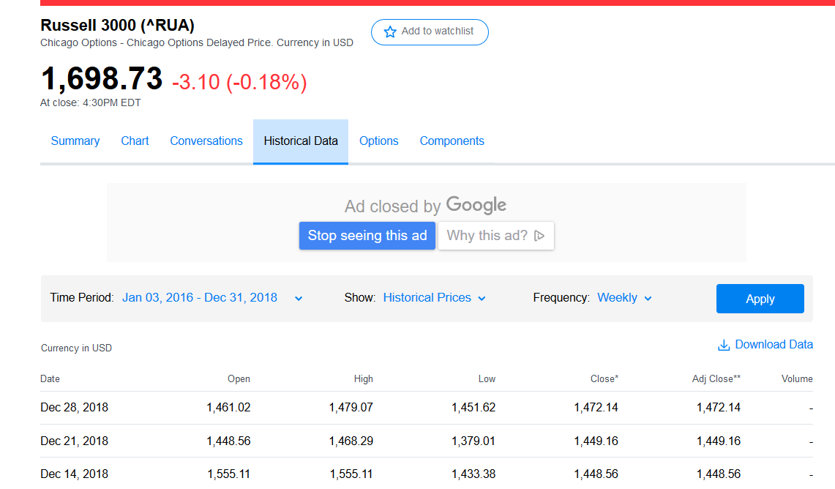

Use US 1-month T-bill rate to proxy for the risk free asset. The data is from <https://www.treasury.gov/resource-center/data-chart-center/interest-rates/Pages/TextView.aspx?data=yield>

The 1-month T-bill rate from 2016 to 2018 (quoted daily, percentage signs are omitted) is on SAS studio, Middle term exam.

1) You are a risk-averse investor. If the annual acceptance rate is 3%, please fill the table below.

Approximated up to four decimal places

|  |  |  |
| --- | --- | --- |
| 2016-2018 | Russell 3000 | NVIDIA |
| Weekly return’s mean | 0.0018 | 0.0118 |
| Weekly return’s standard deviation | 0.0182 | 0.0659 |
| Sharpe-ratio | 0.0875 | 0.17574 |
| Safety first ratio | .0660 | 0.1698 |
| Probability of return less than the acceptable level | 0.4737 | 0.4326 |

NVIDIA- The probability that the stock will be less than the acceptable level is 43%.

Russell 3000- The probability that the stock will be less than the acceptable level is 47%.

Return’s mean/expected return is the profit or loss an investor anticipates on an investment. Not wise to make investment decisions on basis of this only.

Return’s standard deviation measures market and security volatility & predict performance trends.

SFratio provides a probability of getting a minimum required return on a portfolio. An investor’s optimal decision is to choose the portfolio with the highest SF ratio.

Sharpe-ratio-The greater the portfolio’s Sharpe-ratio, the better its risk-adjusted performance.

2) Which one (Russell 3000 or NVIDIA) is more appealing to you and why. (Open question, no more than 80 words)?

I will invest in NVIDIA. Reasons are as follows: -

SF ratio provides a probability of getting a minimum required return on a portfolio. An investor’s optimal decision is to choose the portfolio with the highest SF ratio. NVIDIA’s SF ratio is more than Russell 3000. The greater the portfolio’s Sharpe-ratio, the better its risk-adjusted performance. Sharpe-ratio is more for NVIDIA than Russell 3000. So, I will go with NVIDIA.

codes

/* Q3. Comparison between NVIDIA and Russell 3000*/

/*Nvidia Stock*/

proc import out=NVIDIA

datafile="/home/u37560128/my_courses/xz400/midterm 2019/NVDA weekly price 2016 2018.csv"

dbms=csv replace;

getnames=yes; run;

/*Weekly return*/

data NVIDIA; set NVIDIA;

ret=Adj_Close/lag(Adj_Close)-1; run;

/*Finding Safety First Ratio

= (Expected Return on Portfolio - Investor's minimum required return)/standard deviation of portfolio*/

/*Investor's minimum return = 0.00058

or 3% weekly*/

proc univariate data=NVIDIA noprint; var ret;

output out=nvidiatotals std=stddev mean=Exp_return; run;

proc print data=nvidiatotals; run;

data nvidiatotals; set nvidiatotals;

SFratio=(Exp_return-.00058)/stddev; run;

/*Probability of Safety First ratio*/

data nvidiatotals; set nvidiatotals;

probability=probnorm((.00058-Exp_return)/stddev); run;

/*The probability that the stock will be less than the acceptable

level is 43%. */

/*Sharpe ratio*/

proc import out=treasury

datafile="/home/u37560128/my_courses/Priya_course_work/Financial Analytics/project/1mon_tbill_2016_2018.csv"

dbms=csv replace; getnames=yes; run;

proc means data=treasury noprint;

var BC_1MONTH;

output out=nvidiatbill mean= / autoname; run;

data nvidiasharperatio;

merge nvidiatbill nvidiatotals; run;

data nvidiasharperatio;

set nvidiasharperatio;

Sharpe=(Exp_return-((BC_1MONTH_Mean/100)/52))/stddev; run;

proc print data=nvidiasharperatio; run;

/*1 Russell 3000 statistics*/

proc import out=Russell

datafile="/home/u37560128/my_courses/Priya_course_work/Financial Analytics/project/Russell3000_weekly_2016_2018.csv"

dbms=csv replace; getnames=yes; run;

/*Weekly return*/

data Russell; set Russell;

ret=Adj_Close/lag(Adj_Close)-1; run;

/*Find the Safety First Ratio

= (Expected Return on Portfolio - Investor's minimum required return)/standard deviation of portfolio*/

/*Investor's minimum return = 0.00058

or 3% weekly*/

proc univariate data=Russell noprint;

var ret;

output out=russelltotals std=stddev mean=Exp_return; run;

data russelltotals; set russelltotals;

SFratio=(Exp_return-0.00058)/stddev; run;

/*Probability of Safety First ratio*/

data russelltotals; set russelltotals;

probability=probnorm((0.00058-Exp_return)/stddev); run;

/*The probability that the stock will be less than the acceptable level is 47% . */

/*Sharpe ratio*/

proc import out=treasury

datafile="/home/u37560128/my_courses/Priya_course_work/Financial Analytics/project/1mon_tbill_2016_2018.csv"

dbms=csv replace; getnames=yes; run;

proc means data=treasury noprint;

var BC_1MONTH;

output out=russelltbill mean= / autoname; run;

data russellsharperatio;

merge russelltbill russelltotals; run;

data russellsharperatio;

set russellsharperatio;

Sharpe=(Exp_return-((BC_1MONTH_Mean/100)/52))/stddev; run;

proc print data=russellsharperatio; run;

Result:

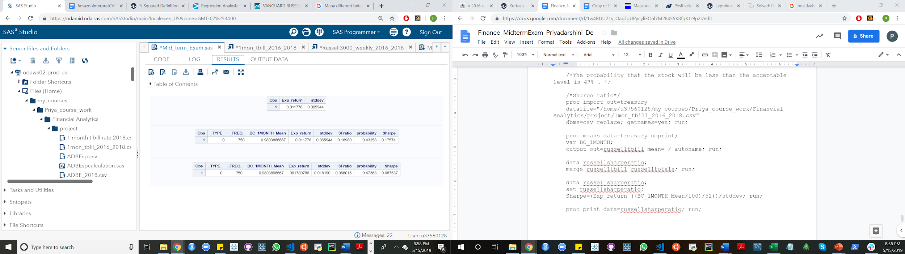

1. NVDA CAPM (30 points)

Use the CAPM model:

Rit - Rft= αi + βi *(Rmt - Rft) +εit

One-month T-bill rate is a proxy for the risk free asset.

Russell 3000 is a proxy for the market portfolio.

1. Provide the following regressions:

|  |  |
| --- | --- |
| CAPM model | NVIDIA |
| Intercept | 0.00702 |
| Intercept’s p value | 0.0874 |
| Beta coefficient | 1.7939 |
| Beta’s P value | 0.0001 |

/***************************NVIDIA CAPM************************************/

proc import out=NVIDIA

datafile="/home/u37560128/my_courses/xz400/midterm 2019/NVDA weekly price 2016 2018.csv"

dbms=csv replace;

getnames=yes; Datarow=2;

run;

proc import out=riskfree

datafile="/home/u37560128/my_courses/Priya_course_work/Financial Analytics/project/1mon_tbill_2016_2018.csv"

dbms=csv replace; getnames=yes; datarow=2; run;

proc import out=R3000

datafile="/home/u37560128/my_courses/Priya_course_work/Financial Analytics/project/Russell3000_weekly_2016_2018.csv"

dbms=csv replace; getnames=yes; datarow=2; run;

proc contents data=nvidia; run;

proc contents data=riskfree; run;

proc contents data=r3000; run;

data nvidia1; set nvidia; nvidia_return=Adj_Close/lag(Adj_Close)-1; run;

data r1; set r3000; r_return=Adj_Close/lag(Adj_Close)-1;

rename date=rdate; run;

data riskfree1; set riskfree;

tdate=datepart(new_date);

ttime=timepart(new_date);

format tdate MMDDYY10. ttime time8.;

t_weeklyreturn=BC_1MONTH/100/52; run;

proc sort data=nvidia1; by date; run;

proc sort data=r1; by rdate; run;

proc sort data=riskfree1; by tdate; run;

proc sql;

create table nvidia_reg as select

nvidia1.nvidia_return, nvidia1.date, r1.r_return, r1.rdate, riskfree1.t_weeklyreturn, riskfree1.tdate

from nvidia1,r1, riskfree1

where nvidia1.date=riskfree1.tdate and nvidia1.date=r1.rdate and riskfree1.tdate=r1.rdate

order by nvidia1.date, r1.rdate, riskfree1.tdate; quit;

data nvidia_reg1;

set nvidia_reg;

rp=nvidia_return-t_weeklyreturn; /*Stock return premium, or stock excess return*/

mrp=r_return-t_weeklyreturn; /*market return premium, or market excess return*/

run;

ods graphics on;

proc reg data=nvidia_reg1;

capm: model rp=mrp; run;

ods graphics off;

/*6Q

NVIDIA's weekly return-.03/52=0.007+1.794*(.06/52)

NVIDIA's weekly return=

0.007+(1.794*.06/52)+(.03/52)=0.0096.

annual return= (.0096*365/7)=.5030 */

Result

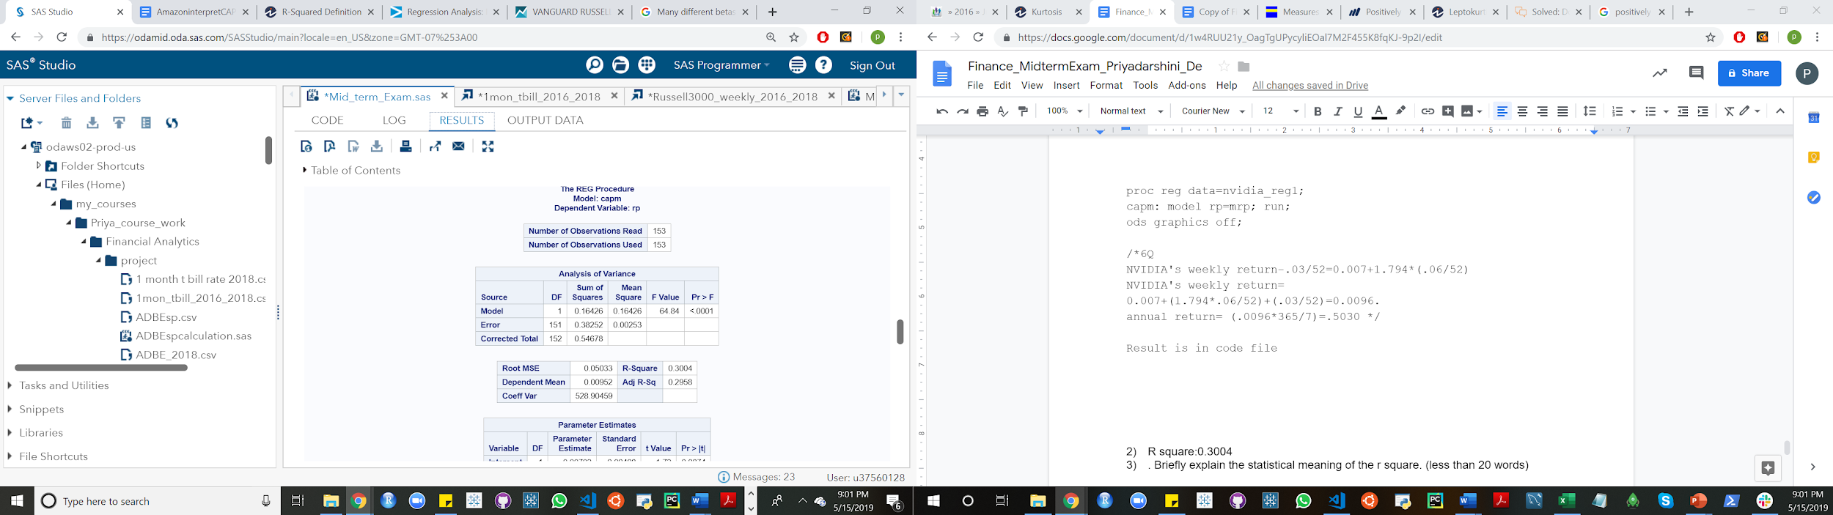

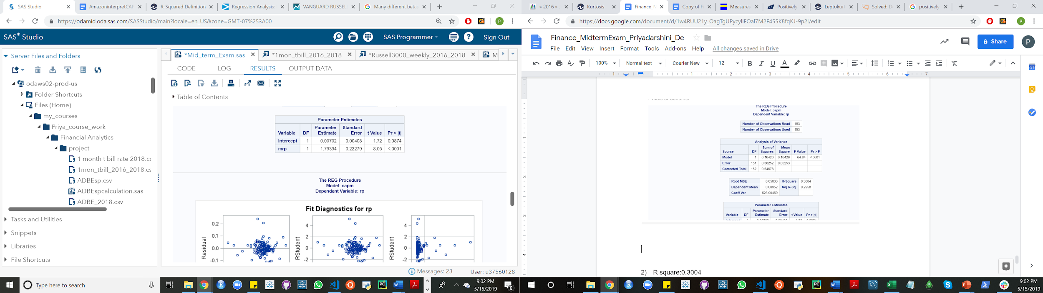

1. R square:0.3004
2. . Briefly explain the statistical meaning of the r square. (less than 20 words)

R^2-it is the percentage of the response variable variation that is explained by a linear model

1. Is NVIDA’s beta larger than 1, or less than 1? What is the economic meaning? (less than 20 words)

NVIDIA’s beta is larger than 1(it is 1.79). It suggests the NVIDIA’s stock is more volatile/higher risk than the benchmark such as Russell 3000/market portfolio for U.S stocks.

1. Does NVIDA have a statistically significant alpha? If yes, what is the economic meaning? (less than 20 words)

NVIDIA has alpha of .00702 with p-value .0874. A positive alpha for NVIDIA stock/portfolio means that it has outperformed its benchmark/market portfolio here Russell 3000.

Yahoo Finance’s [beta](http://investexcel.net/calculate-stock-beta-with-excel/) is calculated from monthly price for the previous 36 months, relative to the S&P 500.

Quote from Yahoo Finance’s beta(5/7/2019): Beta(3 Y Monthly) of NVIDIA is 2.28.

1. Briefly list three reasons why your beta value is different from Yahoo Finance.

Reasons:

1. Beta is calculated in relation to a bench mark, such as S&P 500 for U.S stocks. So, in the quote the benchmark is S&P 500 i.e the market portfolio or the benchmark. I calculated beta holding Russell 3000 as the benchmark.
2. Also the time frame matters since it is different in both the cases.For NVIDIA 1/3/2016-12/31/2018

Russell 3000 1/3/2016- 12/31/2018

T-bill 2016-2018.

The time frame in the quote is different.

3. Standard beta is called levered which means that it reflects the capital structure of the company(including the financial risk linked to the debt level). Unlevered beta(or ungeared beta) compares the risk of an unlevered company(i.e with no debt in capital structure) to the risk of the market. Unlevered beta is generally lowered than the levered beta. However, unlevered beta can be higher than the levered beta when the net debt is negative(meaning the company has more cash than debt.There is no information from the quote that whether it is levered or unlevered beta.

4.Many different betas can be calculated for a given stock. The main common variables that affect beta calculations are time period, the reference date, the sampling frequency for closing prices and the references index.

7) If I expect the market risk premium is 6% p.a. in 2019 and the risk free rate is 3% p.a. in 2019, use your regression estimate to find: NVDA’s annual return.

NVIDIA's weekly return-.03/52=0.007+1.794*(.06/52)

NVIDIA's weekly return= 0.007+(1.794*.06/52)+(.03/52)=0.0096.

annual return= (.0096*365/7)=.5030

NVIDIA’s annual return is .5030.